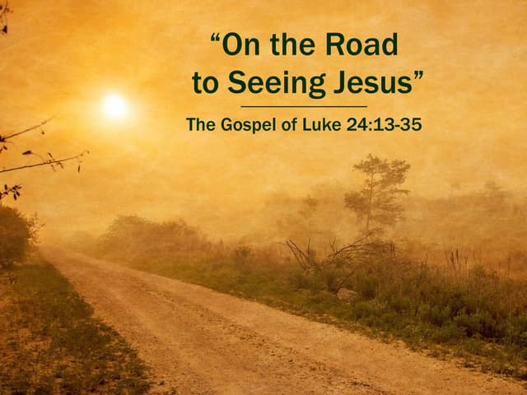

St. Christopher’s Episcopal Church

Holy Eucharist: Rite II

The Third Sunday of Easter
April 19, 2026
9:30 a.m.

St. Christopher’s Episcopal Church
10233 W. Peoria Avenue * Sun City AZ 85351
623-972-1100 * office@stchristophers-az.org

St. Christopher’s Episcopal Church
Holy Eucharist Rite I
Sunday, April 19. 2026

Liturgy of the Word
Prelude
Announcements |  | Chinenye Anako
Processional | Shine, Jesus, Shine | Attached
Opening Acclamation |  | BCP 77
Confession & Absolution |  | BCP 79
Invitatory & Psalter |  | BCP 80
LORD, open our lips
And our mouth shall proclaim our praise

All: Glory to the FATHER and to the SON and to the HOLY SPIRIT. As it was in the beginning, is now and will be forever. Amen.
Alleluia!
Venite |  | BCP 82
Psalm | Psalm 116, 1-3, 10-17 | Attached
All: Glory to the FATHER and to the SON and to the HOLY SPIRIT. As it was in the beginning, is now and will be forever. Amen.
Alleluia!
First Reading | Acts 2: 14a. 36=41 | Attached
Canticle 10 | The Second Song of Isaiah | BCP 86
All: Glory to the FATHER and to the SON and to the HOLY SPIRIT. As it was in the beginning, is now and will be forever. Amen.
Alleluia!
Second Reading |  |  | 1 Peter 1: 17-23 |  |  |  |  |  | Attached
Canticle 11 |  |  | The Third Song of Isaiah |  |  |  |  |  | BCP 87
Gospel Hymn |  |  | Glorify Thy Name |  |  |  |  |  | Attached
Gospel |  |  | Luke 24: 13-35 |  |  |  |  |  | Attached
Sermon |  |  |  |  |  |  |  |  | Mr. Dick Young
Apostle’s Creed |  |  |  |  |  |  |  |  |  | BCP 96
Suffrage B |  |  |  |  |  |  |  |  | BCP 98
The Collect of the Day |  |  |  |  |  |  |  |  | Attached
Collect for Sundays |  |  |  |  |  |  |  |  | BCP 98
Collect for Peace |  |  |  |  |  |  |  |  | BCP 99
Collect for Grace |  |  |  |  |  |  |  |  | BCP 100
Prayers of the People Form VI |  |  |  |  |  |  |  |  |  | Attached
The Peace |  |  |  |  |  |  |  |  | BCP-360
Birthdays/Anniversaries/Travel Blessings, Special Prayers |  |  |  |  |  |  | BCP Inside Cover
Offertory Sentence |  |  |  |  |  |  |  | BCP 376
Offertory Anthem
Doxology |  | Praise God From Whom All Blessings Flow |  |  |  |  |  | H-380, v. 3
The Lord’s Prayer | Our Father |  |  |  |  | Hymnal Inside Front Cover
Eucharist from Reserve Sacrament

Fraction Anthem |  | Christ Our Passover |  | S-155
Lay Eucharistic Minister’s Prayer |  |  |  | BCP Inside Front Cover
Communion Hymn | I Am The Bread of Life |  | H-335
Post Communion Prayer |  |  | BCP 365
General Thanksgiving |  |  | BCP 101
Prayer of St. Chrysostom |  |  | BCP 102
Dismissal Hymn | Joyful, Joyful, We Adore Thee |  | H-376
Concluding Blessing |  |  | BCP 102
St. Christopher’s uses the following texts as worship aides:
The Book of Common Prayer = BCP
The 1982 Hymnal = H
Wonder, Love & Praise Hymnal = WLP

Today’s Worship Leaders
Celebrant: | The Rev Troy Mendez
Verger: | Patty Emanuelson
Crucifer: | Connor Abel
Gospel Bearer | Betty Roddy
First Reading and Psalm | Dick Young
Second Reading | Marva Martinez
Prayers of the People | Patty Emanuelson
Chalice Bearers: | Betty Roddy & Connor Abel
Music Director | Mr. Don Palm

St. Christopher’s Staff
The Rev. Gerardo Brambila, Rector
Cathy Sheredy, Administrative Assistant
Arturo Jaramillo, Sexton
Don Palm, Music Director & Organist
Arturo & Isabel Jaramillo, Hispanic Music Leader & Vocalists

Vestry Members
Patty Emanuelson, Senior Warden
Bill Masters, Junior Warden
Diane Plein, Clerk of the Vestry
Mona Guarino, Treasurer
Chinenye Anako, Member-at-Large
Marva Martinez, Member-at-Large
Mary Salgado, Member-at-large
Mike Soock , Member-at-Large
Dick Young, Member-at-Large

Do you know someone who would benefit from prayer? Contact us! Would you like more information about something you read in the announcements? Contact us! Do you have an idea for fellowship or fund-raising? Contact us! Maybe you would like to talk with Fr. Gerardo? Contact us! Have a pastoral emergency (hospitalization, accident, family issues, something similar)? Contact us! Lots of information on the message! And you can leave one too!

But, if you have a pastoral emergency, please call Fr. Gerardo at 602-405-4588 and leave a message.

Church Office Hours:
Tuesday, Wednesday, Thursday, Friday
9:00 a.m. – 1:00 p.m.
Office Phone: 623-972-1100.

Collect of the Day

O God, whose blessed Son made himself known to his disciples in the breaking of bread: Open the eyes of our faith, that we may behold him in all his redeeming work; who lives and reigns with you, in the unity of the Holy Spirit, one God, now and forever. Amen.

First Lesson

Acts 2: 14a,36-41

Peter, standing with the eleven, raised his voice and addressed the crowd, “Let the entire house of Israel know with certainty that God has made him both Lord and Messiah, this Jesus whom you crucified.”

Now when they heard this, they were cut to the heart and said to Peter and to the other apostles, “Brothers, what should we do?” Peter said to them, “Repent, and be baptized every one of you in the name of Jesus Christ so that your sins may be forgiven; and you will receive the gift of the Holy Spirit. For the promise is for you, for your children, and for all who are far away, everyone whom the Lord our God calls to him.” And he testified with many other arguments and exhorted them, saying, “Save yourselves from this corrupt generation.” So those who welcomed his message were baptized, and that day about three thousand persons were added.

The Psalm
Psalm 116: 1-3, 10-17

- I love the Lord, because he has heard the voice of my supplication, *
because he has inclined his ear to me whenever I called upon him.
- The cords of death entangled me; the grip of the grave took hold of me; *
I came to grief and sorrow.
- Then I called upon the Name of the Lord: *
"O Lord, I pray you, save my life."
10. How shall I repay the Lord *
for all the good things he has done for me?
11. I will lift up the cup of salvation *
and call upon the Name of the Lord.
12. I will fulfill my vows to the Lord *
in the presence of all his people.
13. Precious in the sight of the Lord *
is the death of his servants.
14. O Lord, I am your servant; *
I am your servant and the child of your handmaid; you have freed me from my bonds.
15. I will offer you the sacrifice of thanksgiving *
and call upon the Name of the Lord.
16 I will fulfill my vows to the Lord *
in the presence of all his people,
17. In the courts of the Lord'S house, *
in the midst of you, O Jerusalem. Hallelujah!

All: Glory be to the Father and to the Son and to the Holy Spirit. As it was in the beginning, is now and will be forever. Amen

The Epistle
1 Peter 1: 17-23

If you invoke as Father the one who judges all people impartially according to their deeds, live in reverent fear during the time of your exile. You know that you were ransomed from the futile ways inherited from your ancestors, not with perishable things like silver or gold, but with the precious blood of Christ, like that of a lamb without defect or blemish. He was destined before the foundation of the world, but was revealed at the end of the ages for your sake. Through him you have come to trust in God, who raised him from the dead and gave him glory, so that your faith and hope are set on God.

Now that you have purified your souls by your obedience to the truth so that you have genuine mutual love, love one another deeply from the heart. You have been born anew, not of perishable but of imperishable seed, through the living and enduring word of God.

The Holy Gospel
Luke 24: 13-35

Now on that same day two of Jesus' disciples were going to a village called Emmaus, about seven miles from Jerusalem, and talking with each other about all these things that had happened. While they were talking and discussing, Jesus himself came near and went with them, but their eyes were kept from recognizing him. And he said to them, “What are you discussing with each other while you walk along?” They stood still, looking sad. Then one of them, whose name was Cleopas, answered him, “Are you the only stranger in Jerusalem who does not know the things that have taken place there in these days?” He asked them, “What things?” They replied, “The things about Jesus of Nazareth, who was a prophet mighty in deed and word before God and all the people, and how our chief priests and leaders handed him over to be condemned to death and crucified him. But we had hoped that he was the one to redeem Israel. Yes, and besides all this, it is now the third day since these things took place. Moreover, some women of our group astounded us. They were at the tomb early this morning, and when they did not find his body there, they came back and told us that they had indeed seen a vision of angels who said that he was alive. Some of those who were with us went to the tomb and found it just as the women had said; but they did not see him.” Then he said to them, “Oh, how foolish you are, and how slow of heart to believe all that the prophets have declared! Was it not necessary that the Messiah should suffer these things and then enter into his glory?” Then beginning with Moses and all the prophets, he interpreted to them the things about himself in all the scriptures.

As they came near the village to which they were going, he walked ahead as if he were going on. But they urged him strongly, saying, “Stay with us, because it is almost evening and the day is now nearly over.” So he went in to stay with them. When he was at the table with them, he took bread, blessed and broke it, and gave it to them. Then their eyes were opened, and they recognized him; and he vanished from their sight. They said to each other, “Were not our hearts burning within us while he was talking to us on the road, while he was opening the scriptures to us?” That same hour they got up and returned to Jerusalem; and they found the eleven and their companions gathered together. They were saying, “The Lord has risen indeed, and he has appeared to Simon!” Then they told what had happened on the road, and how he had been made known to them in the breaking of the bread.

The Prayers of the People Form VI

L: In peace, we pray to you, Lord God. For all people in their daily life and work;
People: For our families, friends, and neighbors, and for those who are alone.
L: For this community, the nation, and the world;
People: For all who work for justice, freedom, and peace.
L: For the just and proper use of your creation;
People: For the victims of hunger, fear, injustice, and oppression.
L: For all who are in danger, sorrow, or any kind of trouble;
People: For those who minister to the sick, the friendless, and the needy.
L: For the peace and unity of the Church of God;
People: For all who proclaim the Gospel, and all who seek the Truth.
L: For Sean, our Presiding Bishop, Jennifer, our Bishop, Gerardo, our Rector; and for all bishops and other ministers;
People: For all who serve God in his Church.
L: Almighty God, we commend to your gracious care and keeping all the men and women of our Armed Forces serving in our military serving at home and abroad, including the United States Air Force, Army, Coast Guard, Marines, Navy, Space Force and Merchant Marines. We pray specifically for Matt, Zach, Christopher, and Tierra.
People: Defend them day-by-day with your heavenly grace; strengthen them in their trials and temptations; give them courage to face the perils which beset them; grant them a sense of your adding presence wherever they may be.
L: For the special needs and concerns of this congregation.
Silence – The People may add their own petitions

L. Hear us, Lord;
People: For your mercy is great.
L: We thank you, Lord, for all the blessings of this life.

Silence - The People may add their own thanksgivings
L: We will exalt you, O God our King;
People: And praise your Name for ever and ever.
L: We pray for all who have died, that they may have a place in your eternal kingdom.

Silence - The People may add their own petitions
L: Lord, let your loving-kindness be upon them;
People: Who put their trust in you.
L: We pray to you also for the forgiveness of our sins.

Silence may be kept.

Leader and People
Have mercy upon us, most merciful Father; in your compassion forgive us our sins, known and unknown, things done and left undone; and so uphold us by your Spirit that we may live and serve you in newness of life, to the honor and glory of your Name; through Jesus Christ our Lord. Amen.

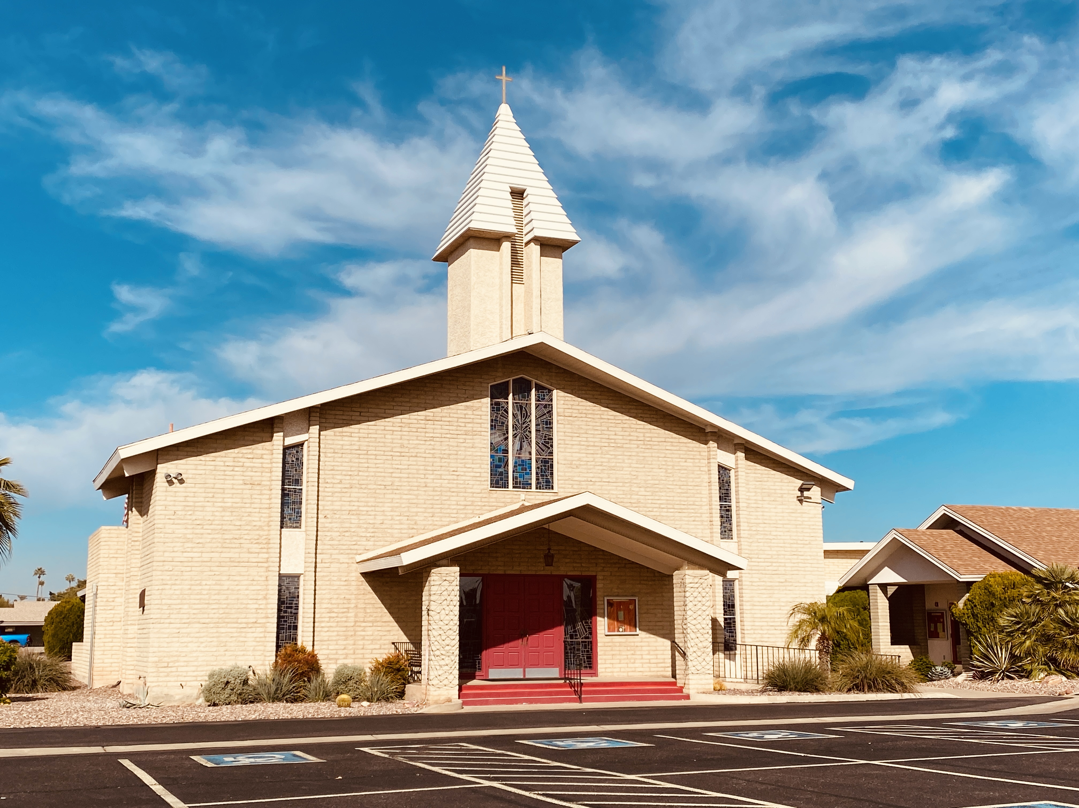

St. Christopher’s Episcopal Church
Weekly Announcements
April 19, 2026

Our Vision: One congregation worshiping and serving in two languages
Our Mission: We are the heart, hands, and feet of Jesus: welcoming all to worship and serving those in need to the glory of God.

Please leave the music inserts and the Prayers of the People inserts in the pews or
in the narthex. Thank you for helping to save administrative costs.

BIBLE STUDY: One of the best ways to connect and grow in our church community is through small groups. Small groups are a place where we can study God's word together and support each other in our faith journeys. The Bible Study takes place on Mondays at 10:00 a.m. in the Parish Hall. Come and join in fellowship.

MORNING PRAYER BY ZOOM ON WEDNESDAYS AT 10:15 AM: If you like morning prayer and can't get to church all the time, feel free to join us on Zoom any Wednesday morning around 10:15-10:45. For more information, contact Patty Emanuelson, Mona Guarino or Beth Mayhew (602-435-5272). Look forward to seeing you!

HELP! HELP! COFFEE HOUR NEEDS YOUR HELP!: Thank you every week to everyone who helps make coffee hour a friendly, yummy gathering! If you haven’t helped with coffee hour before, please consider joining your fellow church members to help serve. You’ll make new friends and have a fun time!
This week’s coffee hour is hosted by Barb and Ron Jackson.
We really appreciate the help everyone gives each week!

FOOD BANK/FOOD DRIVE! Next week is “Breakfast” Sunday. Please bring breakfast items (pancake mix, syrup, oatmeal, dry cereal) to share. Thank you so much for your kindness and generosity.

Food Bank Donations and Bargains/Bookstore Information will be updated in the May 3 weekly announcements

NAME BADGES: We ask that everyone please remember to wear your name badge as it would be of a great help for Fr. Gerardo, new parishioners, and visitors. If you need a name badge, please contact the office. (There are two badges on order, awaiting notification that they are ready.)

PRAYERS
Our first and most vital request is for your prayers. As St. Paul exhorted the Thessalonians, “Brothers and sisters, pray for us” (1 Thessalonians 5: 25). Your spiritual support is the bedrock upon which this ministry is built.

This Week’s Prayer List

One of the ways we care for one another in this church is through prayer. We believe that prayer is powerful and can bring comfort, healing, and peace. Today, we pray for the people below.

* Kelli Abel * Juan Gabriel Aleman * Anne * Jim Barnette * Marcia Bledsoe *Viviana Brambila *
* Judy Broeder *Jan Browning & granddaughter Kia * Tim Buffery * Tom Camper * John Card *
* Clive Chancey * Claudio * Jane Cooley * Jean Durrett * Thomas Dyer * Fr. Gerardo *
* Cathy & Gary Gustin * Michael Heap * Judith * Kim * Gene Lapham * Terry Lewis *
* Domingo Lopez * Ernesto Martinez * Marva Martinez * Brenda McCormick * Mia *
* Shawn Mirigian * Bryan Nance * Marla Karla Pallas * Don Palm * Sandy Patrick * Joanne Porter *
* Ramon * Jill Renner * Rick & Robbie * Betty Roddy * Javier Sanchez * Socorro Sanchez * Sherrie * Stella * Kurt Tetrick * Anna Van Scoter * Victoria * Lynn Viviano-Webb * Ester Zamora *

For those who have died

* Joanne Mola * Eileen Waldren *.


Happy Anniversary in April

Ester & Raul Zamora 53 years
Pamela & Ken Anako 7 years
Judi & Mike Soock 54 years


Happy Birthday to Everyone Celebrating in April

Sam Barrios | April 7 |  | Flo Ball | April 15
Verónica Sanchez | April 9 |  | Katy Young | April 17
Maria Salgado | April 12 |  | Benjamin Anako | April 18
Michael Tetrick | April 12 |  | Jaslene Cortez | April 20
Mike Soock | April 13 |  | Dorothy Anako | April 24
Jennifer Anako | April 15

Vestry
Patti Emanuelson, Senior Warden * Bill Masters, Junior Warden,
Diane Plein, Clerk of the Vestry * Mona Guarino, Treasurer

Members at Large

Chinenye Anako * Marva Martinez * Maria Salgado * Mike Soock * Dick Young *

St. Christopher’s Staff

The Rev. Gerardo Brambila, Rector * Cathy Sheredy, Administrative Assistant
Arturo Jaramillo, Sexton
Don Palm, Music Director & Organist
Arturo & Isabel Jaramillo, Hispanic Music Leaders & Vocalists

Contact Us!

Do you know someone who would benefit from prayer? Contact us! Would you like more information about something you read in the announcements? Contact us! Do you have an idea for fellowship or fund-raising? Contact us! Maybe you would like to talk with Father Gerardo? Contact us! Have a pastoral emergency (hospitalization, accident, family issues, something similar)? Contact us! Lots of information in the message! And you can leave one too!

But, if you have a pastoral emergency, please call Father Gerardo at 602-405-4588 and leave a message.

Church Office Hours: Tuesday, Wednesday, Thursday, Friday from 9:00 a.m. to 1:00 p.m.
Office Phone: 623-972-1100.

